Brain Scan Tumor Classification

Project Examples

Contents

Overview 2

Using the Web Application: *Do I Have A Tumor?* 2

Run Web Application on Localhost 5

Accessing the Model 6

Overview

This document provides users with in-depth examples of how to utilize the published web application, how to run the web application on your own local host, and how to access our model directly.

## Using the Web Application: *Do I Have A Tumor?*

The purpose of this project is to decide if a brain is tumorous or not based on an MRI scan input. To utilize the web application you must have an MRI scan image ready (.jpg, jpeg, .png)

1. Navigate to <http://doihaveatumor.com/>
2. Click the 'Choose File' button, and select the 2D brain scan (.jpg, .jpeg, .png supported) from your file explorer

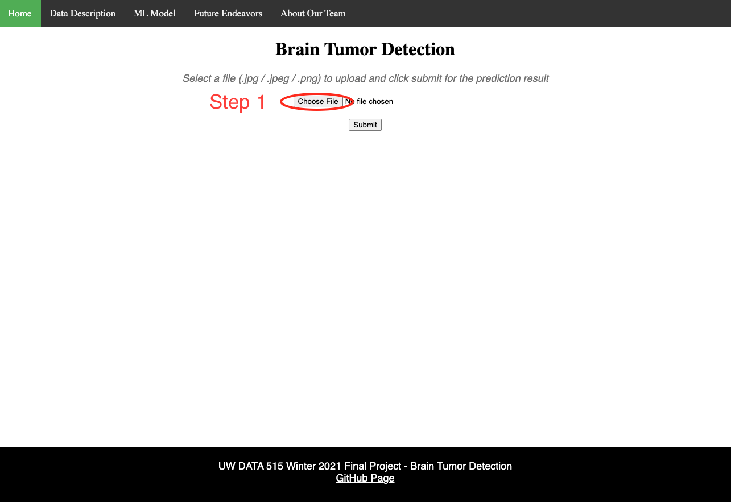

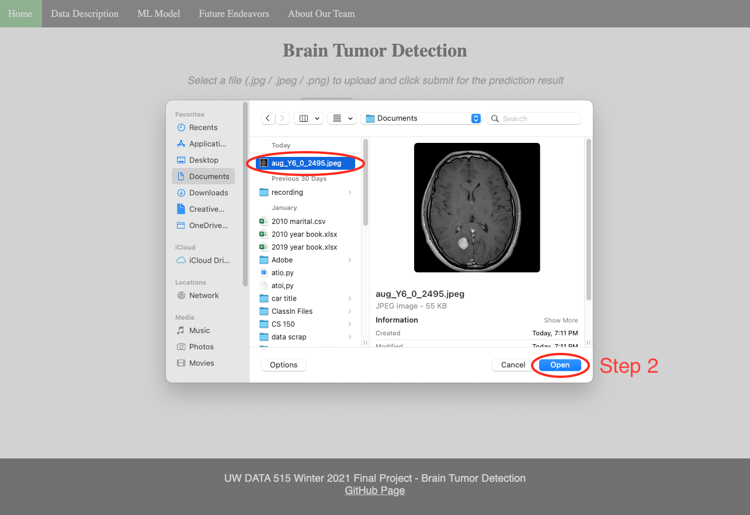

1. Click the 'Submit' button, and wait for the results to display at the top of the page

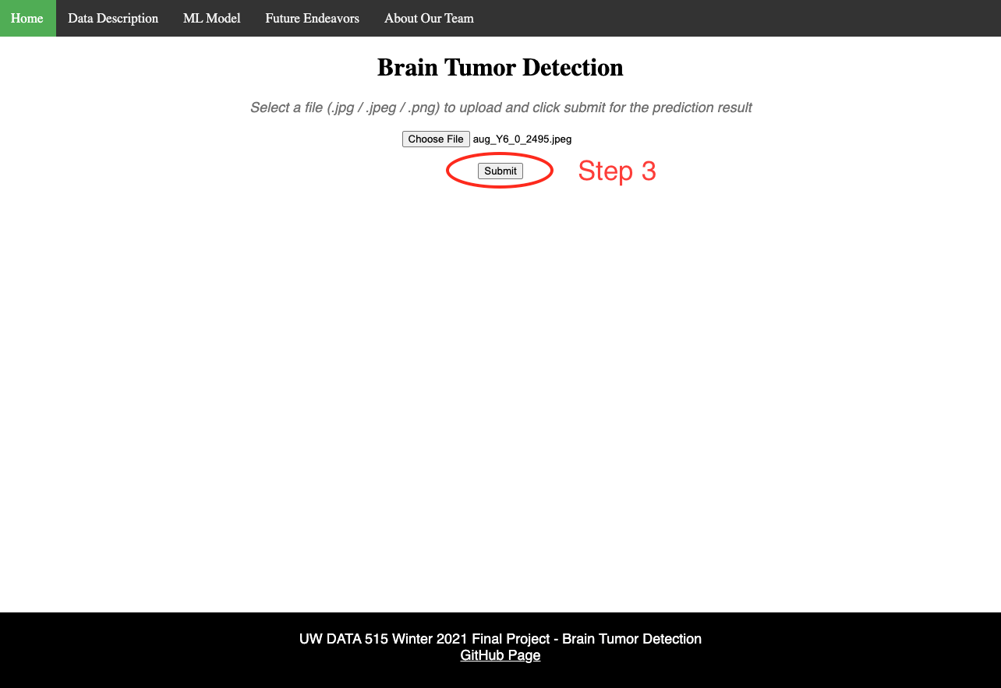

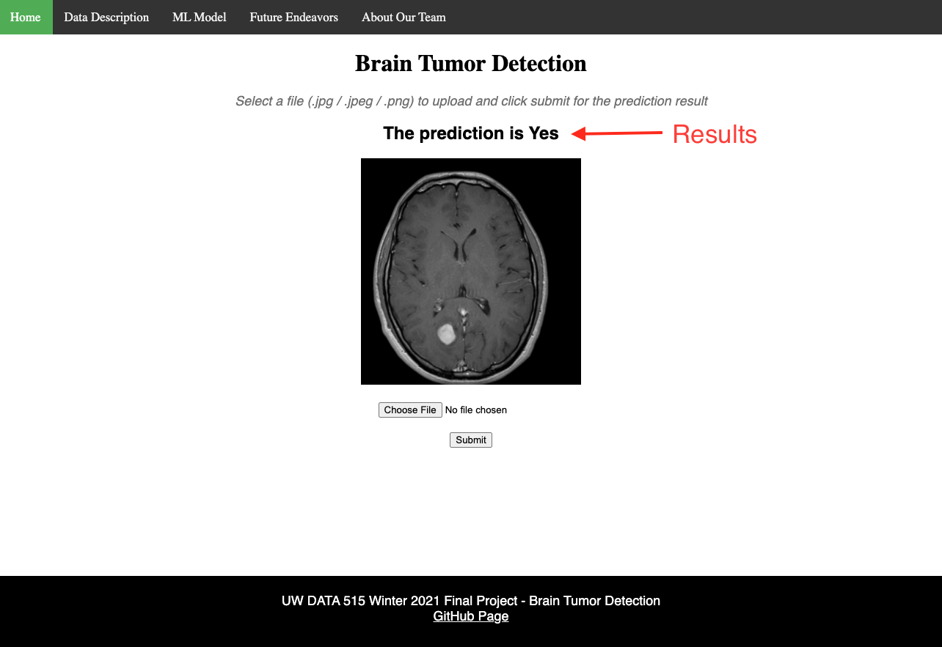

1. Use the top navigation bar to explore more about the model and our development team

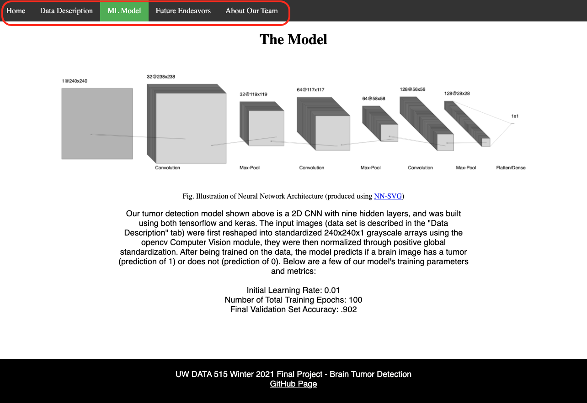

## Run Web Application on Localhost

1. In the command line interface run the following command:

*git clone* [*https://github.com/aaliyahfiala42/DATA515-Brain-Scan-Classification.git*](https://github.com/aaliyahfiala42/DATA515-Brain-Scan-Classification.git)

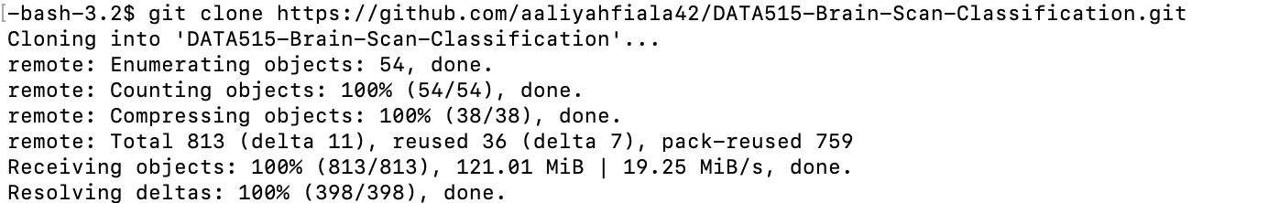

1. Install all required packages by navigating to the root directory (using *cd DATA515-Brain-Scan-Classification*) and run:  
   *python setup.py install*
2. To run the application, navigate to the brain_scan folder (using *cd brain_scan*) andrun:  
   *python application.py*
3. Copy the local host url provided (the http address in the red box) and past the url to a browser of your choice.

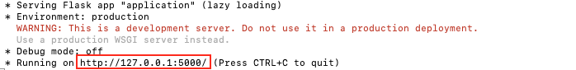

## Accessing the Model

The model training is provided as a Jupyter Notebook located in the “notebooks” folder under the root directory. To access the model, you must have [Jupyter Notebook](https://jupyter.org/install) installed on your local machine, or utilize software such as the [Anaconda Navigator](https://www.anaconda.com/), and follow the instruction below using the Anaconda CMD.exe prompt.

1. In the command line interface run the following command:

*git clone* [*https://github.com/aaliyahfiala42/DATA515-Brain-Scan-Classification.git*](https://github.com/aaliyahfiala42/DATA515-Brain-Scan-Classification.git)

**

1. To run the application, in the command line interface run:

*jupyter notebook*

1. This will then open the Jupyter Notebook interface. Navigate to the *notebooks* and open the *brain_tumor_classification_FINAL* notebook. Now you can view, run, and edit the notebook directly.

